**Question :**

You are required to develop a simple ASP.NET MVC web application using C# that performs the following tasks:

1. Accepts two numerical inputs from the user.

2. Multiply those two numbers.

3. Displays the result of the calculation to the user.

**Question :**

1. In your own words, elaborate what you understand about ASP.NET MVC naming convention.
2. Where are routes registered in ASP.NET MVC Application?
3. What is the purpose of a Razor View Engine in ASP.NET MVC5/6 application?, give some advantages.
4. In what situation would it be appropriate to use a ViewBag?

**Question 2:**

Please provide the code corresponding to the image shown below

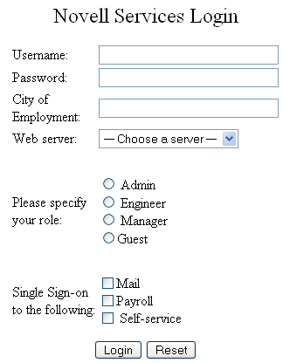

**Question :**

You are required to develop a simple ASP.NET MVC web application using C# that performs the following tasks:

1. Accepts two numerical inputs from the user.

2. Calculates the sum of these two numbers.

3. Displays the result of the calculation to the user.

**Question :**

1. What is ASP.NET MVC?
2. Explain the role of a Controller in an ASP.NET MVC application.
3. What is the purpose of a View in an ASP.NET MVC application?
4. What is Separation of Concerns in ASP.NET MVC?

**Question 3:**

Please provide the code corresponding to the image shown below

